**PRACTICAL-3**

**Aim**: Demonstrate the static routing configuration between 3 router using Cisco packet tracer.

**Theory**:

Static Routing:

* Static Routing is a form of routing that occurs when a router uses a manually-configured routing entry.
* Difference between Static and Dynamic routing is that, static routes are fixed and do not change if the network is changed or reconfigured.
* It is used on a router to maximize routing efficiency and to provide backups in the event that dynamic routing information fails to be exchanged.
* Static routing can also be used in stub networks, or to provide a gateway of last resort.

**Topology:**

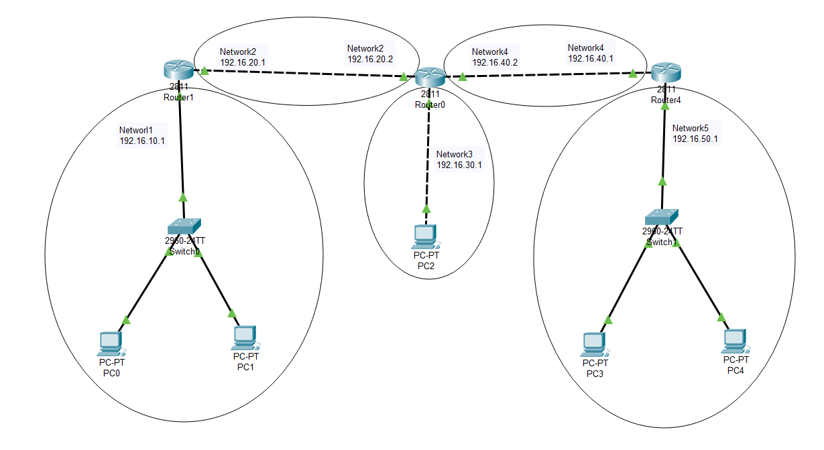

(3.1) Topology of Static Routing

**Steps of Configuration:**

* First step is to create the topology. For that click on the device and drop on workplace and connect all the devices with the necessary cables.
* In order to connect Router2 to Router0;
* Click on Router0 and click on Physical Tab in it. Than select WIC-1ENET from vertical scrollbar.
* Switch off the Router0, click on the switch from Physical View Device;

 🡪 

* Put WIC-1ENET to one of the empty ports of Router0;

 🡪 

* Now, Switch on the Router0.
* Final view of Router0;

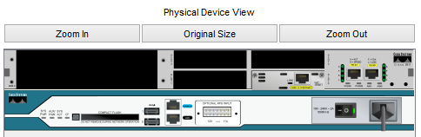

(3.2) Physical Device view of Router0.

* Now, connect Router2 with Router0.
* Provide the IP address and Gateway to Network 1 PCs by clicking on the PC and selecting desktop tab in that IP configuration option;
* PC0 ; IP address : 192.168.10.2
* PC1 ; IP address : 192.168.10.3
* Both; Gateway: 192.168.10.1
* Next step is to configure the Router1 in order to create Static Routing;
* Click on the Router1 and go to CLI tab
* To get into configuration mode, write Router > enable
* To configure the terminal, write Router # configure terminal
* To assign the port to Network 1, write Router(config) # interface fastEthernet 0/0
* To assign IP address to port 0/0, write Router (config-if) # ip address 192.168.10.1 255.255.255.0
* To switch on the router, write Router (config-if) # no shut
* To exit from the interface, write Router (config-if) # exit.
* To assign the port to Network 2, write Router(config) # interface fastEthernet 0/1
* To assign IP address to port 0/1, write Router (config-if) # ip address 192.168.20.1 255.255.255.0
* To switch on the router, write Router (config-if) # no shut
* To exit from the interface, write Router (config-if) # exit.

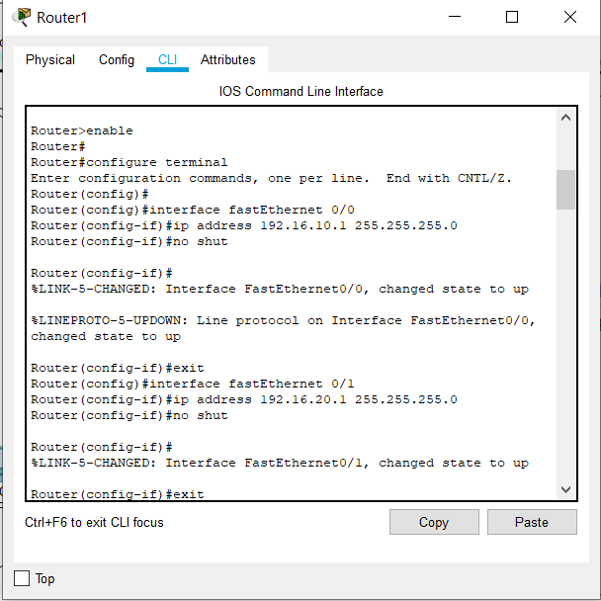

(3.3) Configure the Router1

* Next step is to configure the Router0 in order to create Static Routing;
* Click on the Router0 and go to CLI tab
* To get into configuration mode, write

Router > enable

* To configure the terminal, write

Router # configure terminal

* To assign the port to Network 2, write

Router(config) # interface fastEthernet 0/0

* To assign IP address to port 0/0, write

Router (config-if) # ip address 192.168.20.1 255.255.255.0

* To switch on the router, write

Router (config-if) # no shut

* To exit from the interface, write

Router (config-if) # exit.

* Follow the same steps to configure Router 0’s other ports (0/1 and 0/0/0).

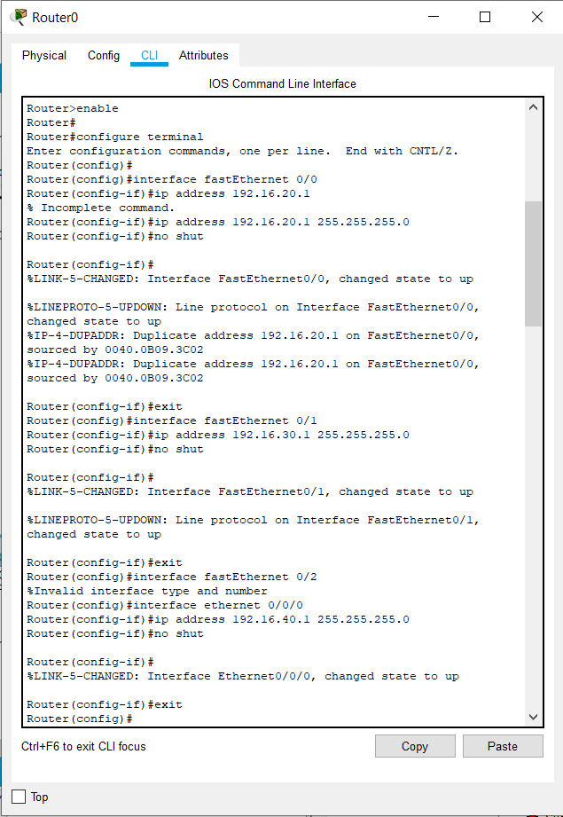

(3.4) Configure the Router0

* Follow the same steps to configure Router 4.

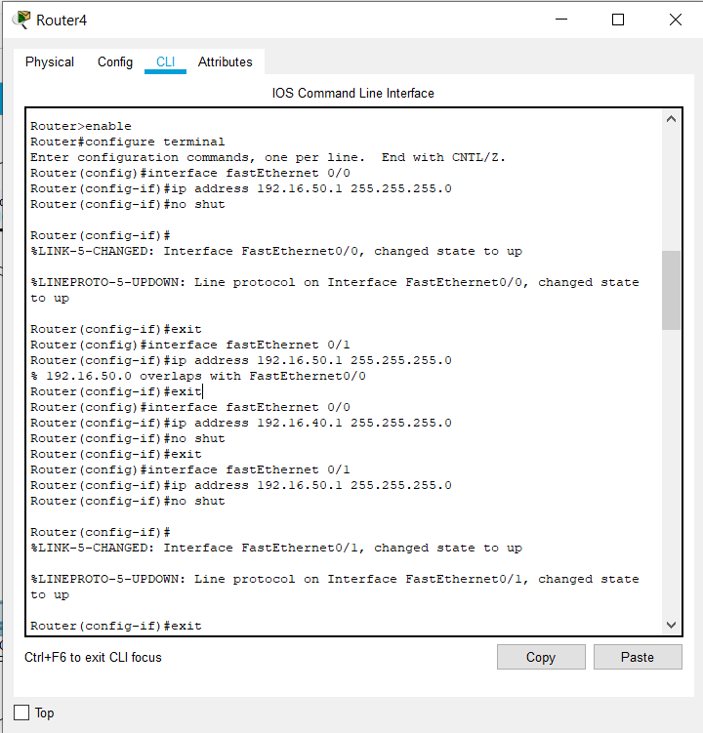

* Next step is to provide route to message From Router 1 to other Routers in order to create Static Routing;
* To provide route to message from Network 1 to Network 3;

Router(config)#ip route 192.168.30.0 255.255.255.0 192.168.20.2

* To provide route to message from Network 1 to Network 4;

Router(config)#ip route 192.168.40.0 255.255.255.0 192.168.20.2

* To provide route to message from Network 1 to Network 5;

Router(config)#ip route 192.168.50.0 255.255.255.0 192.168.20.2

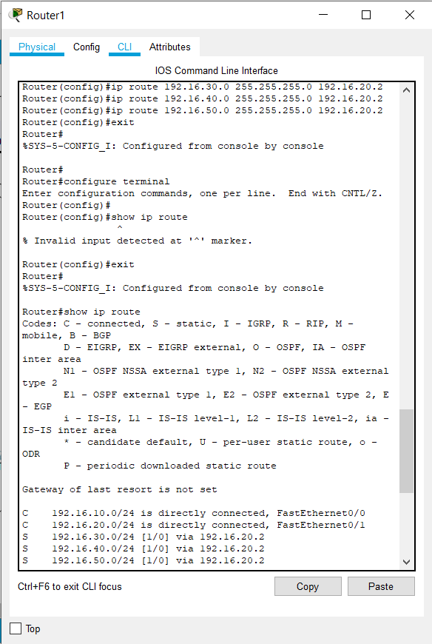

(3.5) Connection b/w Router 1 to Other Routers

* Follow the same steps to provide route to message From Router 0 and Router 4 to other Routers in order to create Static Routing.

**Check Network Topology:**

* To check the topology is working or not drop a package on the one PC of Network 1 and try to receive it by the PC of Network 3.
* Now drop the package on PC of Network 3 and try to receive it by the PC of Network 5.

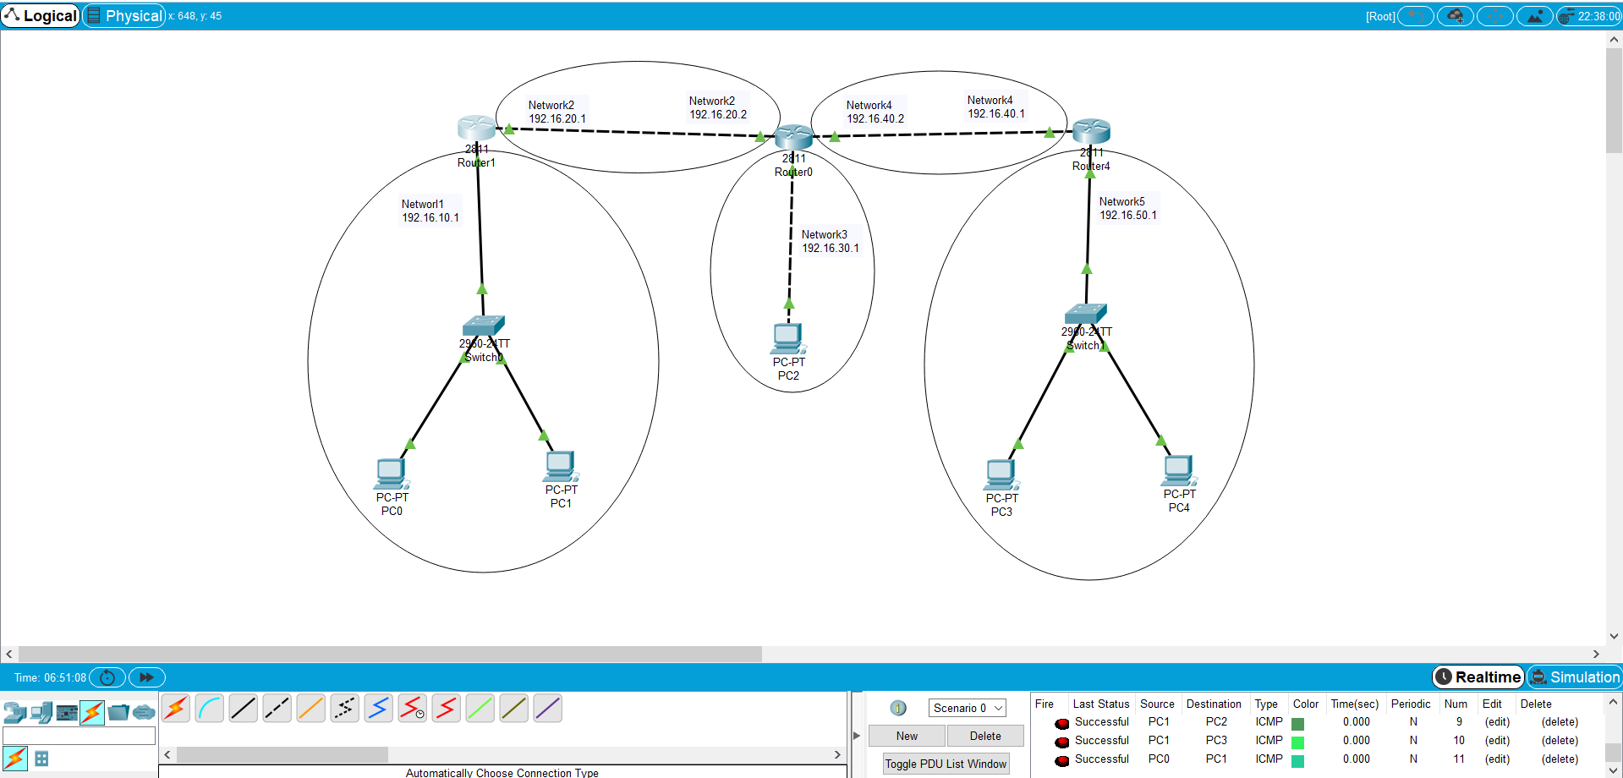

(3.6) Successful Message Passed

**Conclusion:**

From this practical, I have learnt about the configuration of Static Routing and what are the advantages and disadvantage of it by doing live configuration of it in Cisco Packet Tracer.